Name : Sahil Saini Salaria
Reg No. 180905048
Roll No 11 C
Batch C1 IT Labs

Q1

<!DOCTYPE html>
<html>

<head>
<title>Question1</title>
<script src="https://ajax.googleapis.com/ajax/libs/jquery/3.5.1/jquery.min.js"></script>

<script>
$(document).ready(function () {
$("button").click(function () {
$("#image1").animate({ left: '300px' },1000);
$("#table1").animate({ left: '300px' },1000);
})
});
</script>

<style>
table,
th,
td {
text-align: center;
border: 1px solid black;
border-collapse: collapse;
}
</style>
</head>

<body>
<div style="height: 5ch;"></div>
<table id='table1' style="width: 50%; position: relative">
<tr style="background-color: aqua;">
<th>Name</th>
<th>Section</th>
<th>roll no</th>
</tr>
<tr>
<td>Manik</td>
<td>C</td>
<td>12</td>
</tr>
<tr style="background-color: aqua;">
<td>Menaal</td>
<td>C</td>
<td>13</td>
</tr>
<tr>
<td>Harsha</td>
<td>C</td>
<td>14</td>
</tr>
<tr style="background-color: aqua;">
<td>Abhishek</td>
<td>C</td>
<td>15</td>
</tr>
</table>

<div style="height: 5ch;"> </div>

<img id='image1' src="image1.jpg" alt="image" style="height: 400px; width: 400px; position: relative;">

<div style="height: 10ch;"> </div>
<button >Click Me!</button>

</body>

</html>

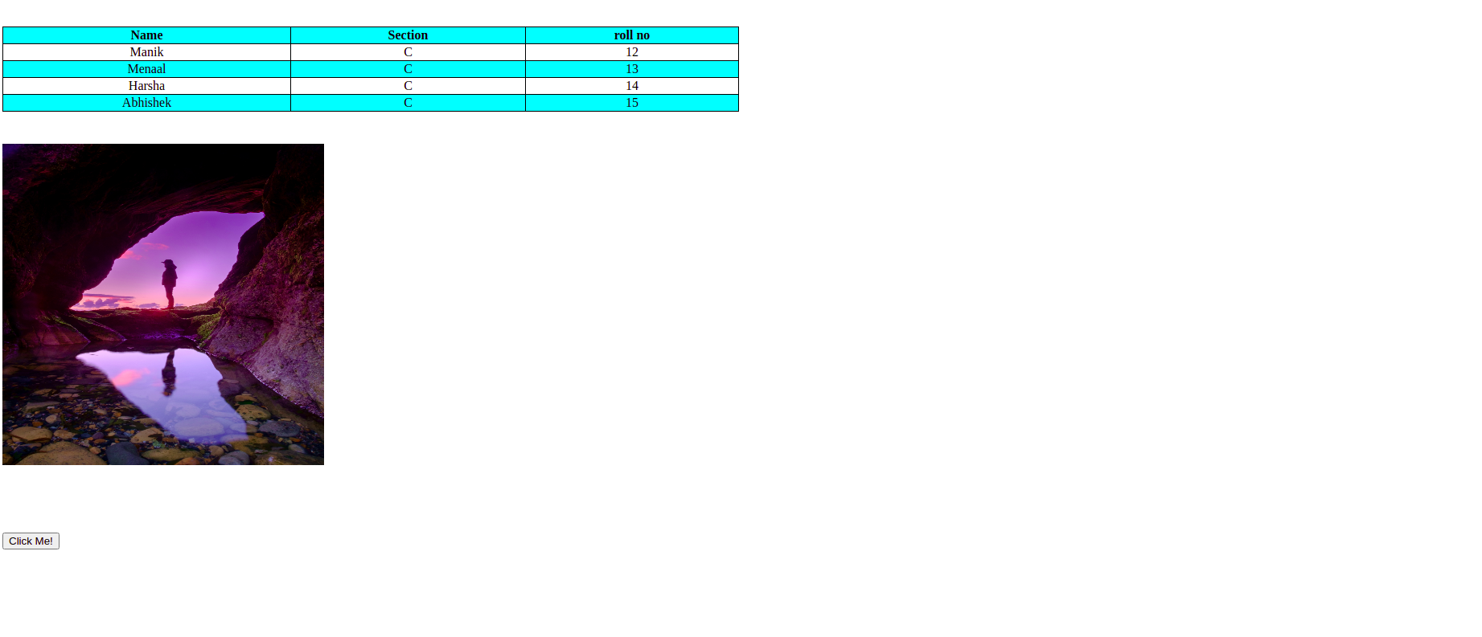

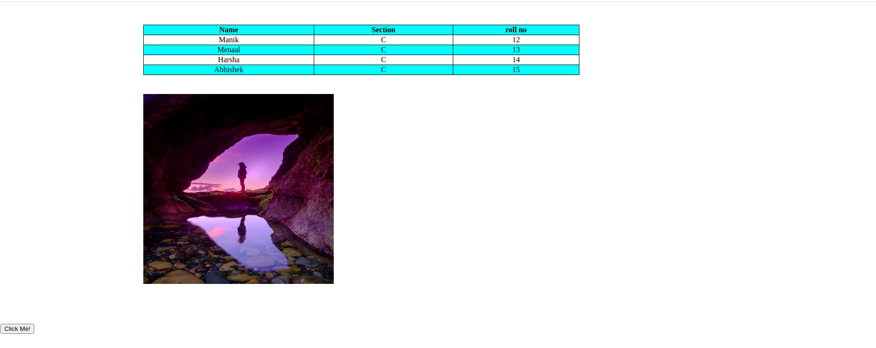

Q2

<html lang="en">
<head>
<title>Question2</title>
<script src="https://ajax.googleapis.com/ajax/libs/jquery/3.5.1/jquery.min.js"></script>
<script>
$(document).ready(
function(){
var value1=""
console.log("hi")
$('button').click(function(evt){
var buttonValue=$(this).html();

if(buttonValue=='Clr')
{
$('input').val('')
value1=''
}
else if(buttonValue=='=')
{
let x=eval(value1)
$('input').val(x)
}
else{
console.log(typeof(buttonValue))
console.log(buttonValue)
value1+=buttonValue
console.log(value1)
$('input').val(value1)
}

})
}

);
</script>
<style>
td{
/* border-collapse: collapse; */
background-color: aqua;
text-align: center;
}
</style>
</head>
<body>

<table border='1'>
<tr>
<td colspan="3" ><input id='txt' type="text" id='col'></td>
<td><button>Clr</button></td>
</tr>
<tr>
<td><button>1</button></td>
<td><button>2</button></td>
<td><button>3</button></td>
<td><button>4</button></td>
</tr>
<tr>
<td><button>5</button></td>
<td><button>6</button></td>
<td><button>7</button></td>
<td><button>8</button></td>
</tr>
<tr>
<td><button>9</button></td>
<td><button>0</button></td>
<td><button>+</button></td>
<td><button>-</button></td>
</tr>
<tr>
<td><button>*</button> </td>
<td><button>/</button></td>
<td><button>.</button> </td>
<td><button>=</button> </td>
</tr>

</table>

</body>
</html>

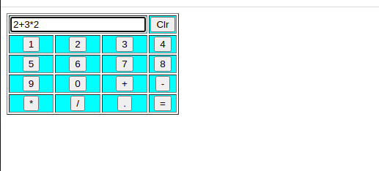

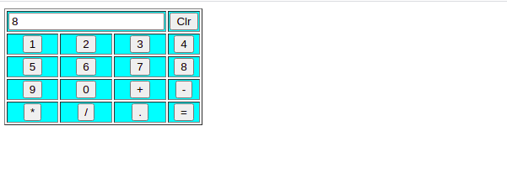
Q3

<!DOCTYPE html>
<html>

<head>
<title>lab1_2</title>
<link rel="stylesheet" type="text/css" href="s3.css">
<script src="https://ajax.googleapis.com/ajax/libs/jquery/3.5.1/jquery.min.js"></script>
<script type="text/javascript">
$(document).ready(function () {
$('button').click(function () {
var x = $('.clr option:selected').text();
$('.poster').css("background", x);
var y = $('.font option:selected').text();
$('.poster').css("font-family", y);
var z = $('.fsiz option:selected').text() + "px";
$('.poster').css("font-size", z);
var a = $('input[name=border]:checked', '.frm').val();
$('.poster').css("border", a);
if ($('.check1').is(":checked") == true) {
$('.pic').css("display", "block");

}
var b = $('.txt1').val();
$('.post').html(b);
})
});
</script>
<style>
.main {
background-color: powderblue;
height: auto;
width: 100%;
margin: auto;
display: flex;
}

.span {
margin: auto;
}

.drop {
flex-basis: 40%;
}

.poster {
flex-basis: 40%;
height: 700px;
width: 700px;

}
</style>
</head>

<body>

<div class="main" style="display: block;">
<div class="drop">
<div class="clr">
<span>Choose a color</span>
<select id="color" name="color">
<option value="Red">Red</option>
<option value="Yellow">Yellow</option>
<option value="Orange">Orange</option>
<option value="Blue">Blue</option>
<option value="Pink">Pink</option>
</select>
</div>

<div style="height: 2ch;"> </div>

<div class="font">
<span>Choose a font</span>
<select id="fnt" name="fnt">
<option value="serif">serif</option>
<option value="fantasy">fantasy</option>
<option value="cursive">cursive</option>
</select>
</div>
<div style="height: 2ch;"> </div>
<div class="fsiz">
<span>Choose font size</span>
<select id="color" name="color">
<option value="17">17</option>
<option value="20">20</option>
<option value="25">25</option>
<option value="27">27</option>
<option value="28">28</option>
</select>
</div>
<div style="height: 2ch;"> </div>
<form class="frm">
<div class="bdr">
<span>Select border style</span><br>
<input type="radio" name="border" class="border" value="none">
<label for="none">none</label><br>
<input type="radio" name="border" class="border" value="Double">
<label for="Double">Double</label><br>
<input type="radio" name="border" class="border" value="Solid">
<label for="Solid">Solid</label><br>
</div>
</form>
<div style="height: 2ch;"> </div>
<div class="check">
<input type="checkbox" name="default" class="check1">
<label>Add default picture</label>
</div>
<div style="height: 2ch;"> </div>
<div class="txt">
<input type="text" name="text" class="txt1">
</div>
<div style="height: 2ch;"> </div>
<button>
submit
</button>
<div style="height: 2ch;"> </div>
</div>
<div class="poster" align='center'; height='100px'>

<div class="post">

</div>
<div class="pic" align='center'>
<div style="height: 100px;"></div>
<img src="images.jpeg" width="200px" height="200px" coords=34,44,270,350>
</div>
</div>
<div style="height: 2ch;"> </div>
</div>
</body>

</html>

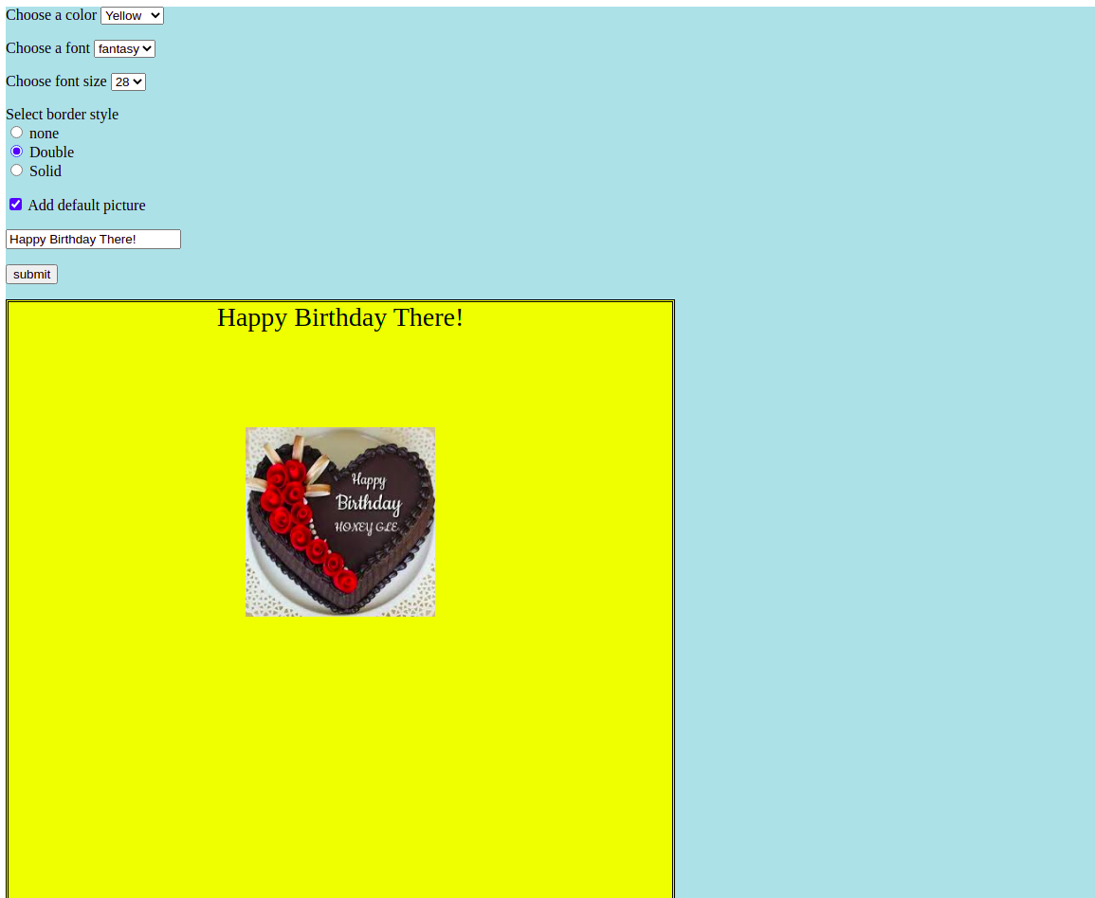

Q4

<!DOCTYPE html>
<html>

<head>
<title>lab1_2</title>
<link rel="stylesheet" type="text/css" href="s4.css">
<script src="https://ajax.googleapis.com/ajax/libs/jquery/3.5.1/jquery.min.js"></script>
<script type="text/javascript">
$(document).ready(function () {
$('button').click(function () {
var mcst, lcst;
var x = $('.clr option:selected').text();
var y = parseInt($('.txt1').val());
var z = parseInt($('.txt2').val());
var tot1 = parseInt('0'), tot2 = parseInt('0');
if (isNaN(y)) {
y = parseInt("0");
}
if (isNaN(z)) {
z = parseInt("0");
}
if (x == 'HP') {
mcst = parseInt("10000");
lcst = parseInt("30000");
}
else if (x == "Nokia") {
mcst = parseInt("7000");
lcst = parseInt("26000");
}
else if (x == "Samsung") {
mcst = parseInt("8500");
lcst = parseInt("416000");
}
else if (x == "Motorola") {
mcst = parseInt("11000");
lcst = parseInt("31000");
}
else if (x == "Apple") {
mcst = parseInt("70000");
lcst = parseInt("260000");
}
if ($('.check1').is(':checked') == true) {
tot1 = mcst * ($('.txt1').val());
}
if ($('.check2').is(':checked') == true) {
tot2 = lcst * ($('.txt1').val());
}
var tot = parseInt(tot1) + parseInt(tot2);
alert("total cost:" + tot);
})
});
</script>
</head>

<body style="background-color: powderblue;">

<h1>Mobile and Laptop shop</h1>

<div style="height: 5ch;"> </div>

<div class="main">
<div class="drop" >

<div class="clr">
<span>Choose a brand</span>
<select id="color" name="color" class="clr">
<option value="HP">HP</option>
<option value="Nokia">Nokia</option>
<option value="Samsung">Samsung</option>
<option value="Motorola">Motorola</option>
<option value="Apple">Apple</option>
</select>
</div>

<div style="height: 5ch;"> </div>

<div class="check">
<input type="checkbox" name="default" class="check1">
<label>Mobiles</label>
<input type="checkbox" name="default" class="check2">
<label>Laptops</label>
</div>

<div style="height: 5ch;"> </div>

<div class="txt">
<label>Mobiles quantity</label>
<input type="number" name="text" class="txt1" placeholder="mobile quantity" value="1">

<div style="height: 5ch;"> </div>

<label>laptops quantity</label>
<input type="number" name="text" class="txt2" placeholder="laptop quantity" value="1">

</div>

<div style="height: 5ch;"> </div>

<button>
Produce bill
</button>
</div>
<div class="poster">
<div class="post">

</div>
</div>
</div>
</body>
</html>
